3.2 Website

3.2.1 Authentication

3.2.1.1 Login
Step 1: Access the FDA System Login Page
The user (Admin, Authority, or Super Admin) navigates to the FDA System administration portal at the official URL: fda-website.vercel.app .
The authentication page is displayed with a split-screen layout:
- Left panel: A branded gradient panel (blue to cyan) displaying the FDA System logo (water-drop icon), the headline 'Flood Monitoring System', and two feature cards: 'Real-time' and 'Safe Route'.
- Right panel: A centered login form area with the title 'Welcome Back' and a subtitle notice explaining this portal is for Admin, Authority, and Super Admin roles only.
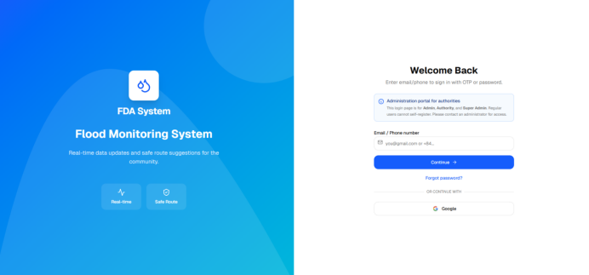
Figure 32: Login – Login Page Overview
Step 2: Enter Email or Phone Number
The user enters their registered email address or phone number into the 'Email / Phone number' input field.
The user then clicks 'Continue' to proceed.
The system calls the identifier-check API to determine the appropriate authentication method for the account.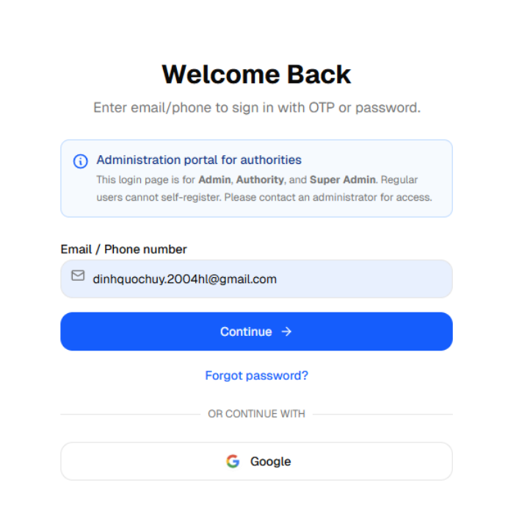
Figure 33: Login – Enter Identifier
Step 3.1: Login with Password
If the system determines the account uses password-based authentication, the form transitions to a password entry step:
- A text line displays: “Account: <user's email/phone>”
- A “Password” field appears with a lock icon on the left and a show/hide eye icon on the right.
- A “Forgot password?” link appears next to the password label.
- A “Sign In” → primary button and a “Back” secondary button are shown.

The user enters their password and clicks 'Sign In' to submit.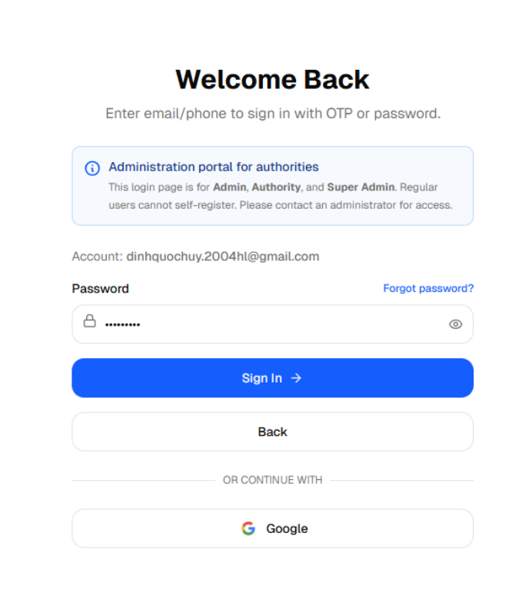
Figure 34: Login – Password Entry Form
Step 3.2: Login with OTP
If the system determines the account uses OTP-based authentication, the system automatically sends an OTP to the identifier and the form transitions to an OTP entry step:
- Header text shows: “OTP sent to: <identifier>”
- A 6-digit OTP input field is displayed.
- A countdown timer shows OTP expiry time (e.g., '4:59').
- “Sign In” primary button and two secondary buttons: “Change email/phone” and “Resend OTP”.

The user enters the 6-digit OTP received via email or phone and clicks “Sign In”.
Figure 35: Login – OTP Entry Form
Step 4: Successful Login – Redirect to Dashboard
Upon successful credential verification, the system:
Validates the user's role (SUPER_ADMIN, ADMIN, or AUTHORITY).
Redirects Admin/Super Admin roles to the '/admin' dashboard.
Redirects Authority roles to the '/authority' dashboard.
Displays a green toast notification: 'Signed in successfully!'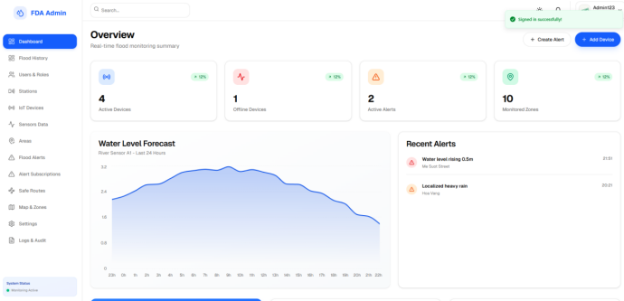
Figure 36: Login – Successful Login (Role-based Redirect)
Step 5: Login with Google Account
As an alternative, the user can click the 'Google' button below the form separator.
- The system calls the Google OAuth initialization API to generate the authorization URL.
- The browser is redirected to Google's sign-in page (accounts.google.com).
- The user selects their Google account and grants permission.
- Google redirects back to /auth/callback, completing authentication and redirecting to the role-based dashboard.
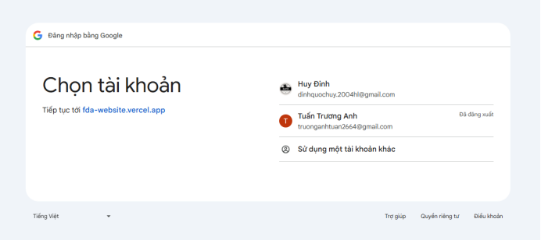
Figure 37: Login – Google OAuth Login Flow

3.2.1.2 Forgot and Reset Password
Step 1: Initiate Forgot Password from the Login Form
On the Login screen (identifier step or password step), the user clicks the 'Forgot password?' link.
The system requires the identifier field to contain a value before initiating forgot password.
If the identifier field is empty, a warning is shown: 'Please enter email or phone number.'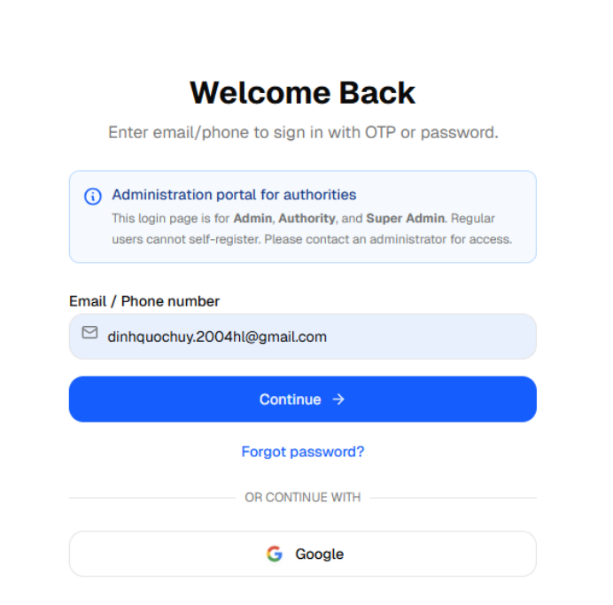
Figure 38: Forgot Password – Trigger Link Location
Step 2: OTP Sent for Password Reset
With a valid identifier entered, the system calls the OTP send API and transitions the form to OTP verification mode (FORGOT_PASSWORD mode).
A success toast is displayed: 'Password reset OTP has been sent!'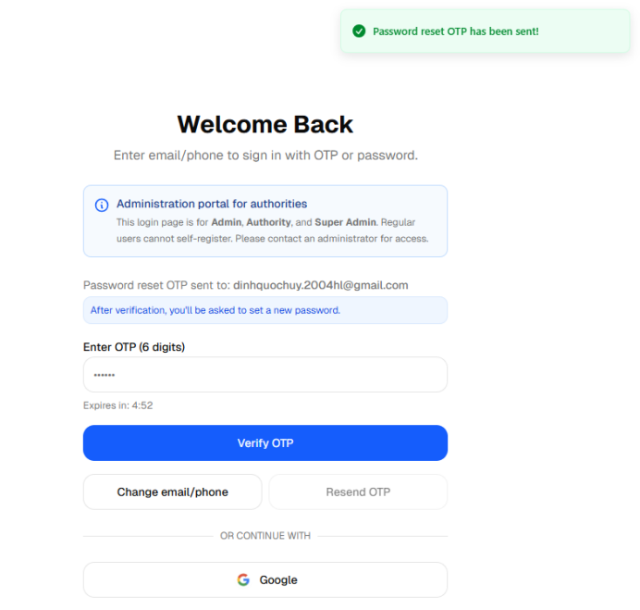
Figure 39: Forgot Password – OTP Sent Confirmation
Step 3: Enter and Verify OTP
The user retrieves the 6-digit OTP from their email or phone.
The user types the OTP into the input field and clicks 'Verify OTP'.
If the OTP is fewer than 6 digits: yellow toast 'OTP must be 6 digits.'
If the OTP has expired, the 'Resend OTP' button becomes clickable to request a new code.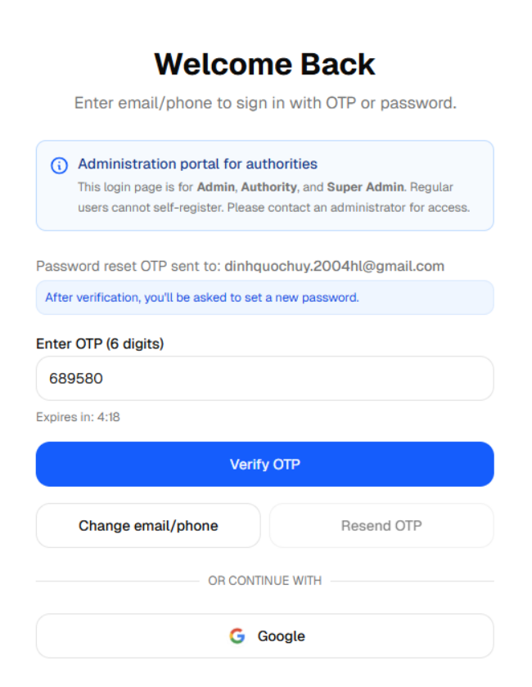
Figure 40: Forgot Password – OTP Input Interaction
Step 4: Set a New Password
Upon successful OTP verification in FORGOT_PASSWORD mode, the system logs the user in and automatically opens the 'Set a new password' modal over the dashboard.
Inside the dialog, the user enters:
- New Password – must satisfy all five security requirements.
- Confirm Password – must match the new password exactly.
Requirements are shown as a real-time checklist:
- At least 8 characters
- Contains uppercase (A-Z)
- Contains lowercase (a-z)
- Contains a number (0-9)
- Contains a special character (!@#$...)

A password match indicator also appears when the user types in the Confirm Password field.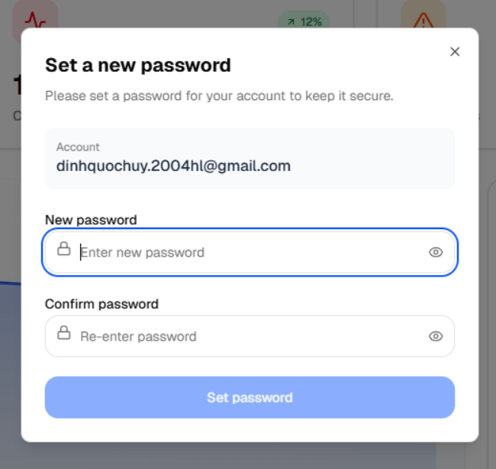
Figure 41: Forgot Password – Set New Password Modal

Step 5: Confirm Reset and Log In Normally
After the user clicks 'Set password' and the API confirms success:
- Green toast: 'Password reset successful!'
- The modal closes automatically.
- The user is fully logged in and can use the system normally.

For future logins, the user signs in with their email and the newly set password (password-based flow).
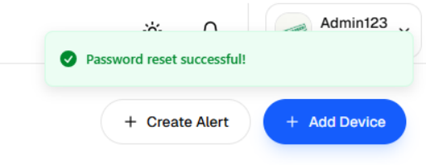
Figure 42: Forgot Password – Password Reset Successful

